1. Try to find the API documentation page of iexcloud.io

<https://iexcloud.io/docs/api/>

2. From now on, you can use Insomnia to call the API.

<https://cloud.iexapis.com/stable/stock/aapl/stats?>

3. Now let’s find the URL for the last 3 months of Apple stock prices in the IEXCloud API.

<https://iex.lewagon.com/stable/stock/aapl/chart/3m>

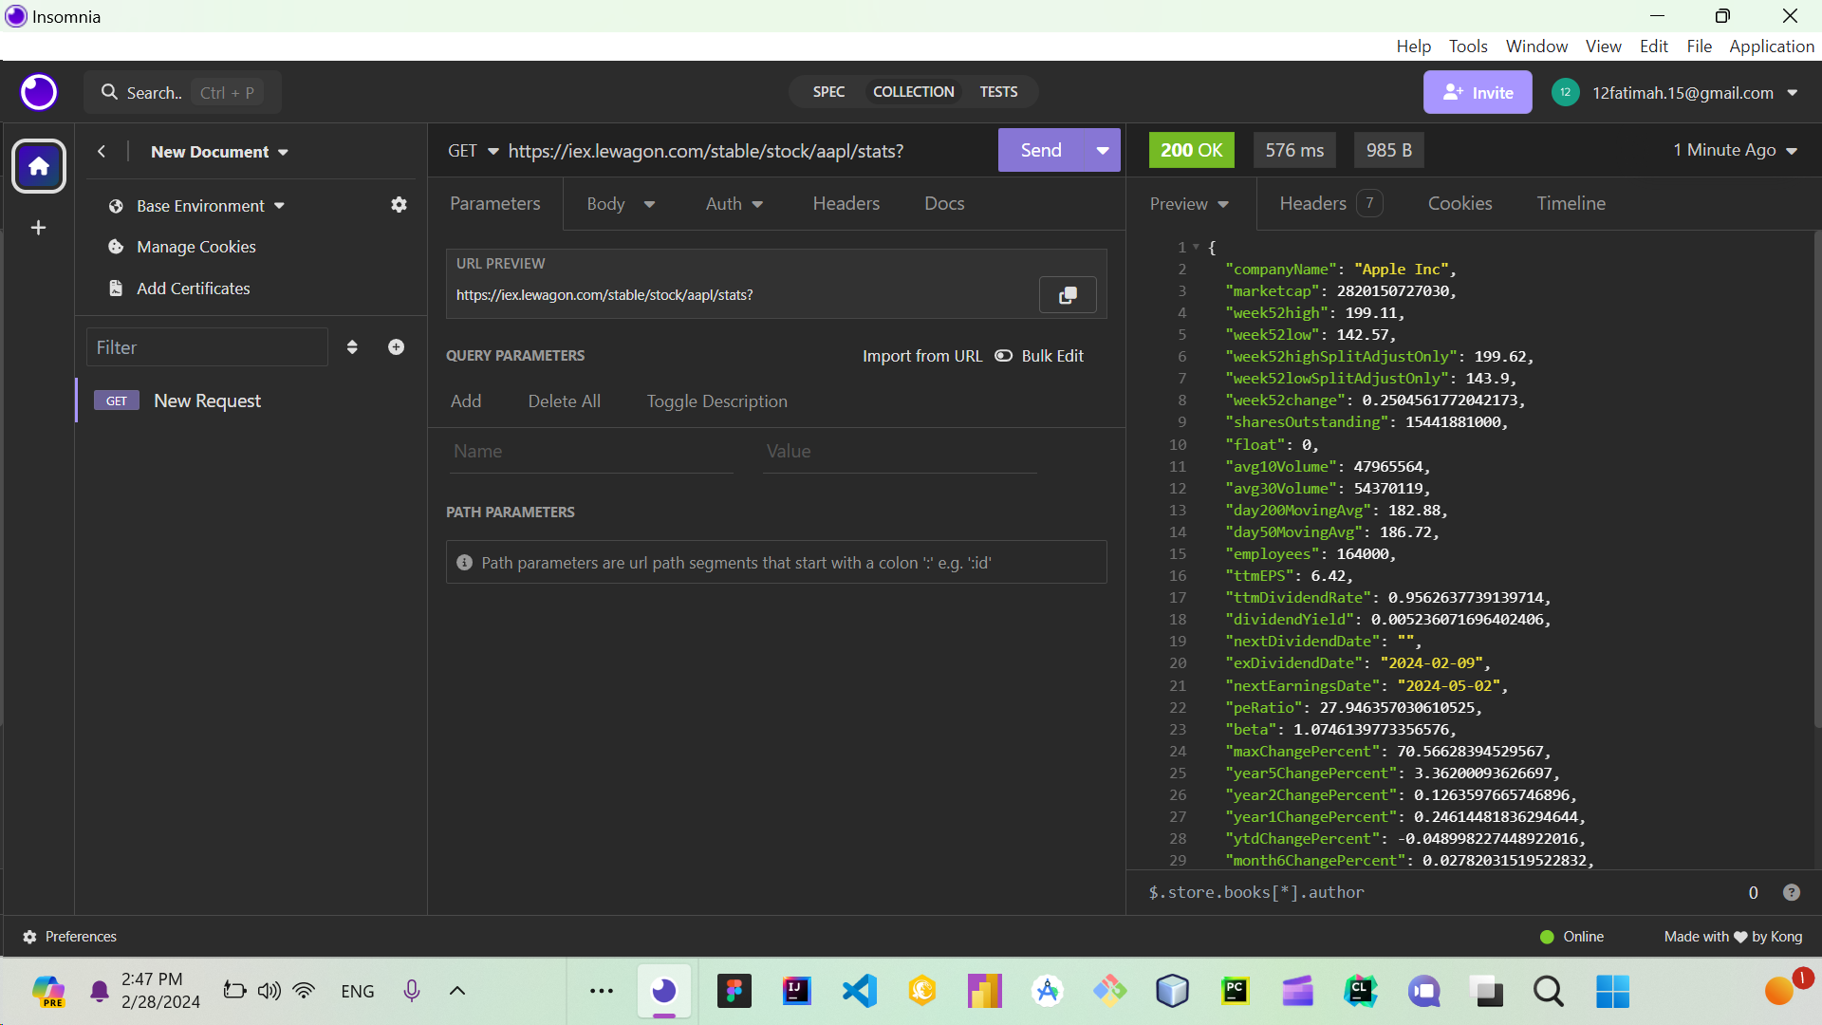

3. Let’s find out what kind of data we can get from this API 🕵️‍♂️

What is the URL of the:

a- Amazon stock prices since last year?

<https://iex.lewagon.com/stable/stock/amzn/chart/1y>

b- Facebook (Meta) market cap?

<https://iex.lewagon.com/stable/stock/meta/stats>

c- Apple’s quarterly research and development spending?

<https://iex.lewagon.com/stable/stock/aapl/financials>

d- Most recent news about Tesla?

<https://iex.lewagon.com/stable/stock/tsla/news/last/1>

e- Performance of the ‘Energy’ sector?

<https://iex.lewagon.com/stable/stock/market/sector-performance>